**This script is used for importing Drawing\ Part Family Template to TC 11.**

* Copy all xml files and it’s exported folders to Target Machine where import is performed.
* Open Teamcenter Shell
* Open DrawingImportList.txt \ PartFamilyIMport.txt for list of all drawings which needs to be imported.

<Desired Item>; < Point to the new Location of xml file and its content need to be changed >

* change directory to \ImportXML.
* Run utility from Teamcenter shell environment by calling import.ksh.
* Enter TC_ROOT, TC_DATA TC User name, TC Password and Group one by one.
* Enter DrawingImportList.txt \ PartFamilyIMport.txt as input file name and Press Enter.
* Check Item Entered in Input file imported in to the TC environment.

DrawingImportList.txt contains path to xml file folder

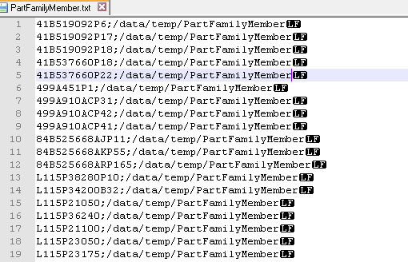

Shell

